|  |  |  |  |  |  |
| --- | --- | --- | --- | --- | --- |
|  | **Scenario** | **Location** | **Distance** | **Time** | **# of Run** |
| **1** | City – Interface with Pedestrian and cars | Downtown Detroit | 3.3 Mile | 28 Minutes | 5 |
| **2** | Highway and Tunnel | I696 - Southfield | 14.2 Mile | 17 Minutes | 10 |
| **3** | City – Traffic Circle | Southfield – Franklin Rd | 1.1 Mile | 3 Minutes | 10 |
| **4** | City – Heavy Traffic | Southfield – Telegraph Rd | 12.2 Mile | 21 Minutes | 10 |
| **5** | City – Interface with Pedestrian and cars | University of Michigan Campus |  |  | 2 |
| **6** | City – Interface with Pedestrian and cars | University of Michigan Campus | 2.8 Miles | 18 Minutes | 5 |

**Honda Hackathon Data Collection**

* Each Data capture run will be targeted based on different possible weather or climate conditions:
* Day light (Good Weather condition)
* Night
* Rain
* Fog
* Snow (very low possibility in October)

**Scenario 1 – Interface with Cars and Pedestrian**

Scenario 1.A was split into scenarios 5 and 6.

Part A - (Downtown Ann Arbor – University of Michigan)

Scenario 6 (Maynard street passing under the building)

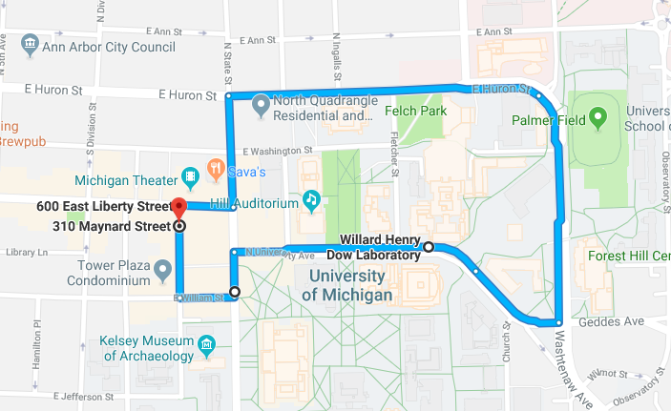

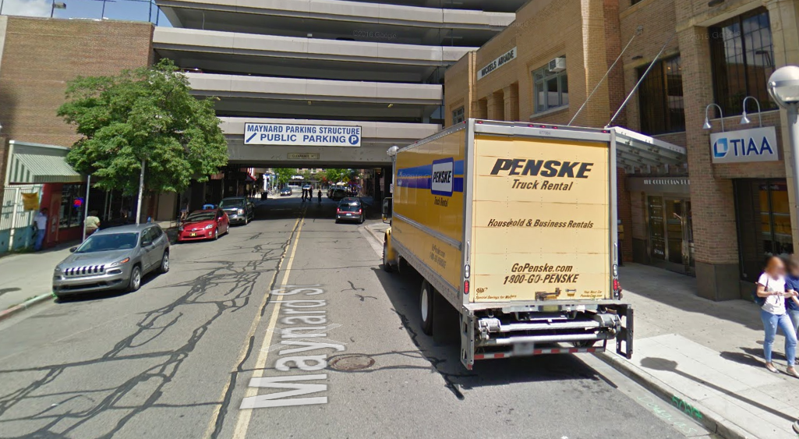

Scenario 5

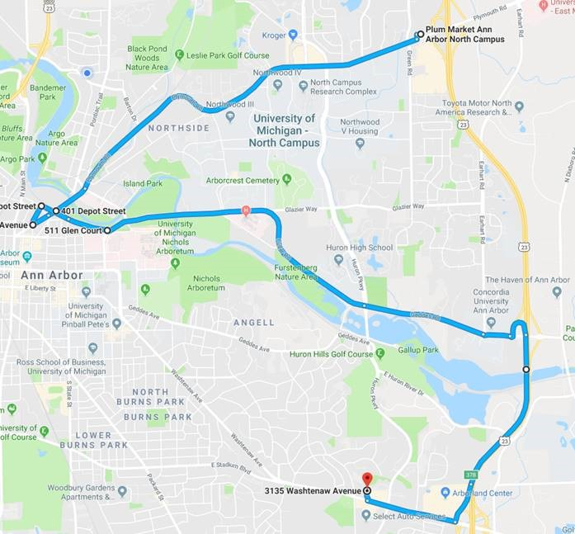

Scenario 1.B - (Downtown Detroit)

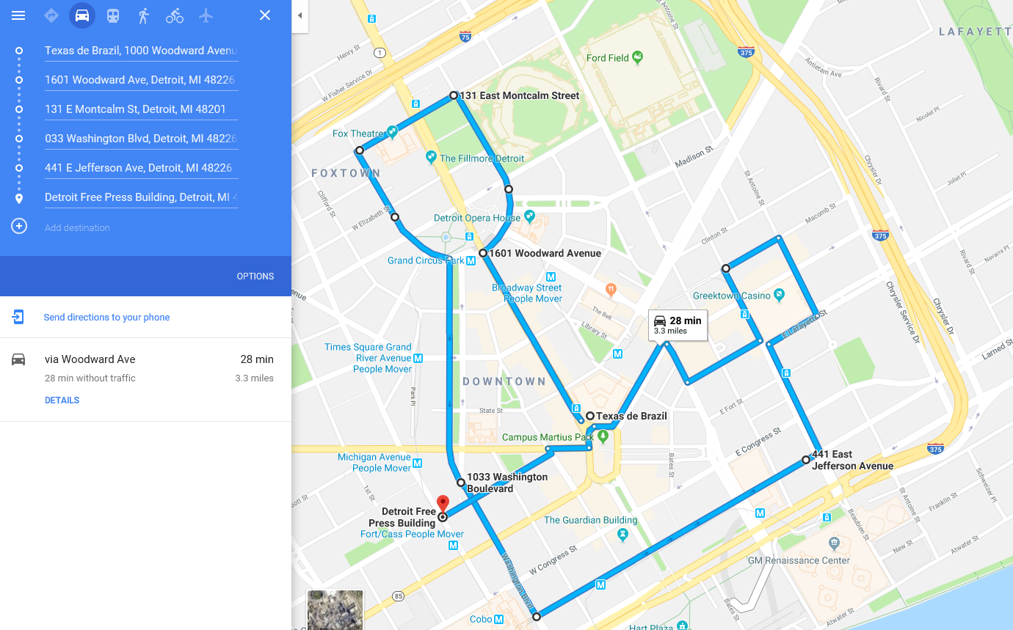

**Scenario 2 – Passing Under Long Bridge** (Close condition to short Tunnel) in I696 Highway

**17 Minutes – 14.2 Miles**

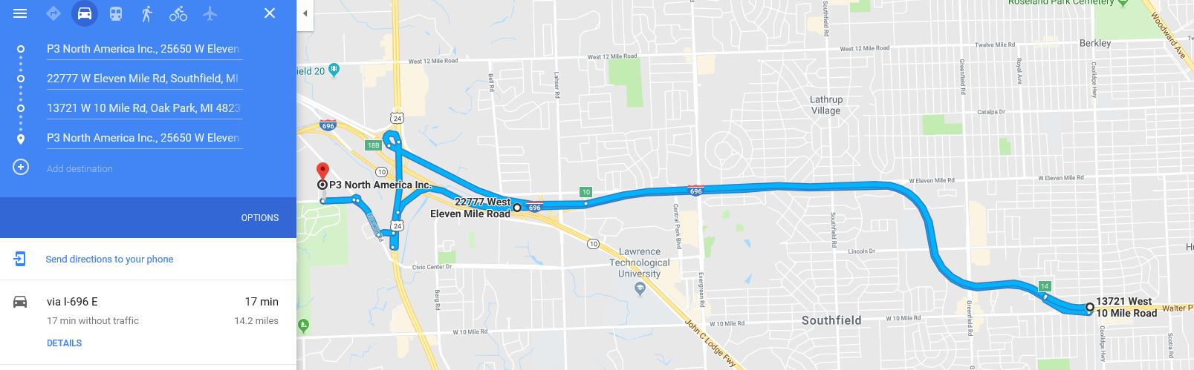

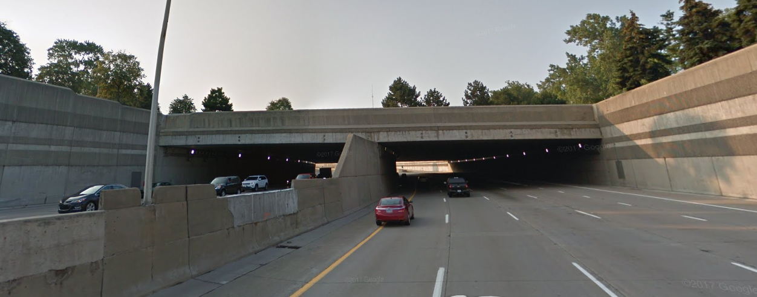

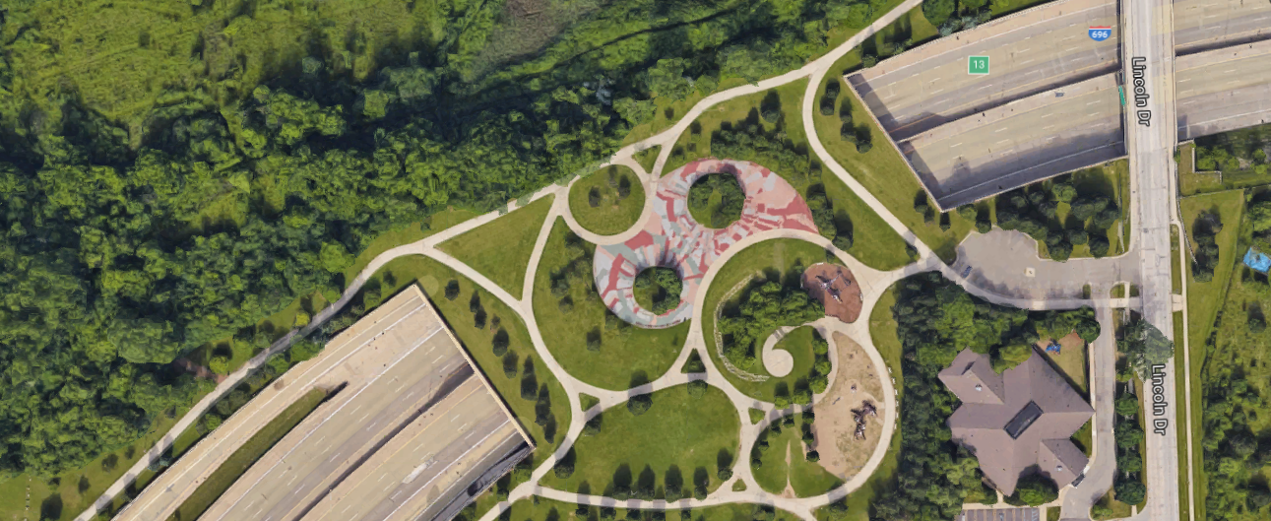

West Bridge (500 Feet Long)

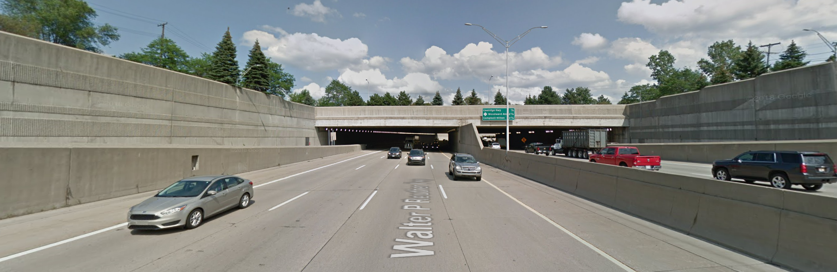

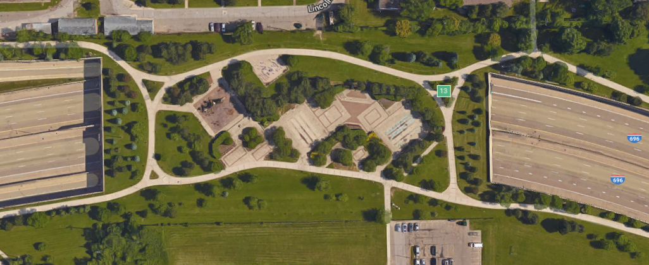

Middle Bridge (650 Feet Long)

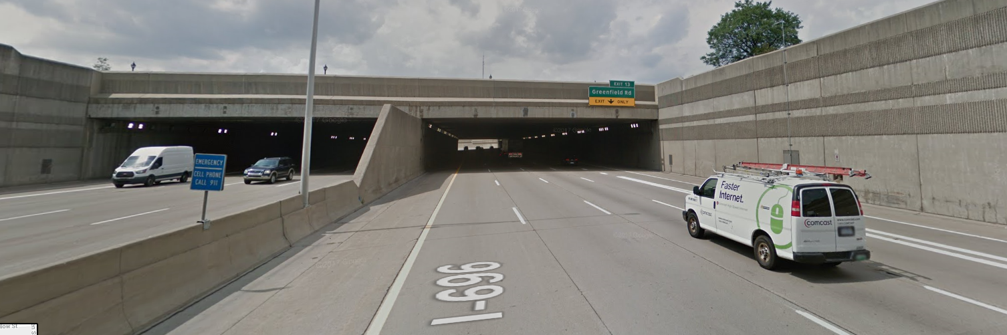

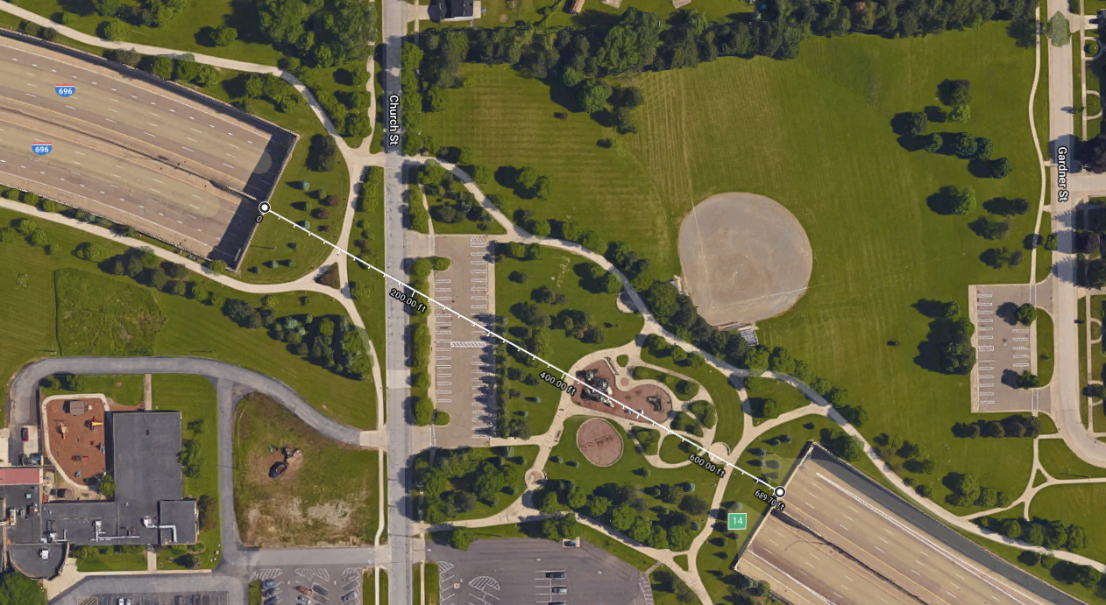

East Bridge (700 Feet Long)

**Scenario 3 – Traffic circle (3 minutes – 1.1 Mile)**

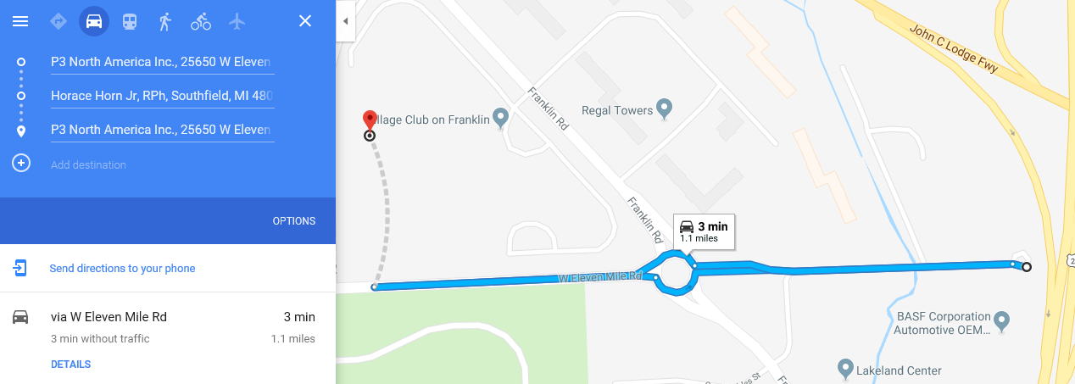

**Scenario 4 – Heavy traffic (21 Minutes – 12 Mile)**

